MACH4METAL

metalworking machinery
Transito 21
6909 DA BABBERICH Netherlands
Tel. +31 (0)316-247123
Fax: +31 (0)316-247956
info@mach4metal.com
www.mach4metal.com

Bank No : 66.52.13.883
IBAN : NL33 INGB 0665 2138 83
BIC : INGBNL2A

PROMECAM Press brake 1200 x 25 T

- Make : PROMECAM France
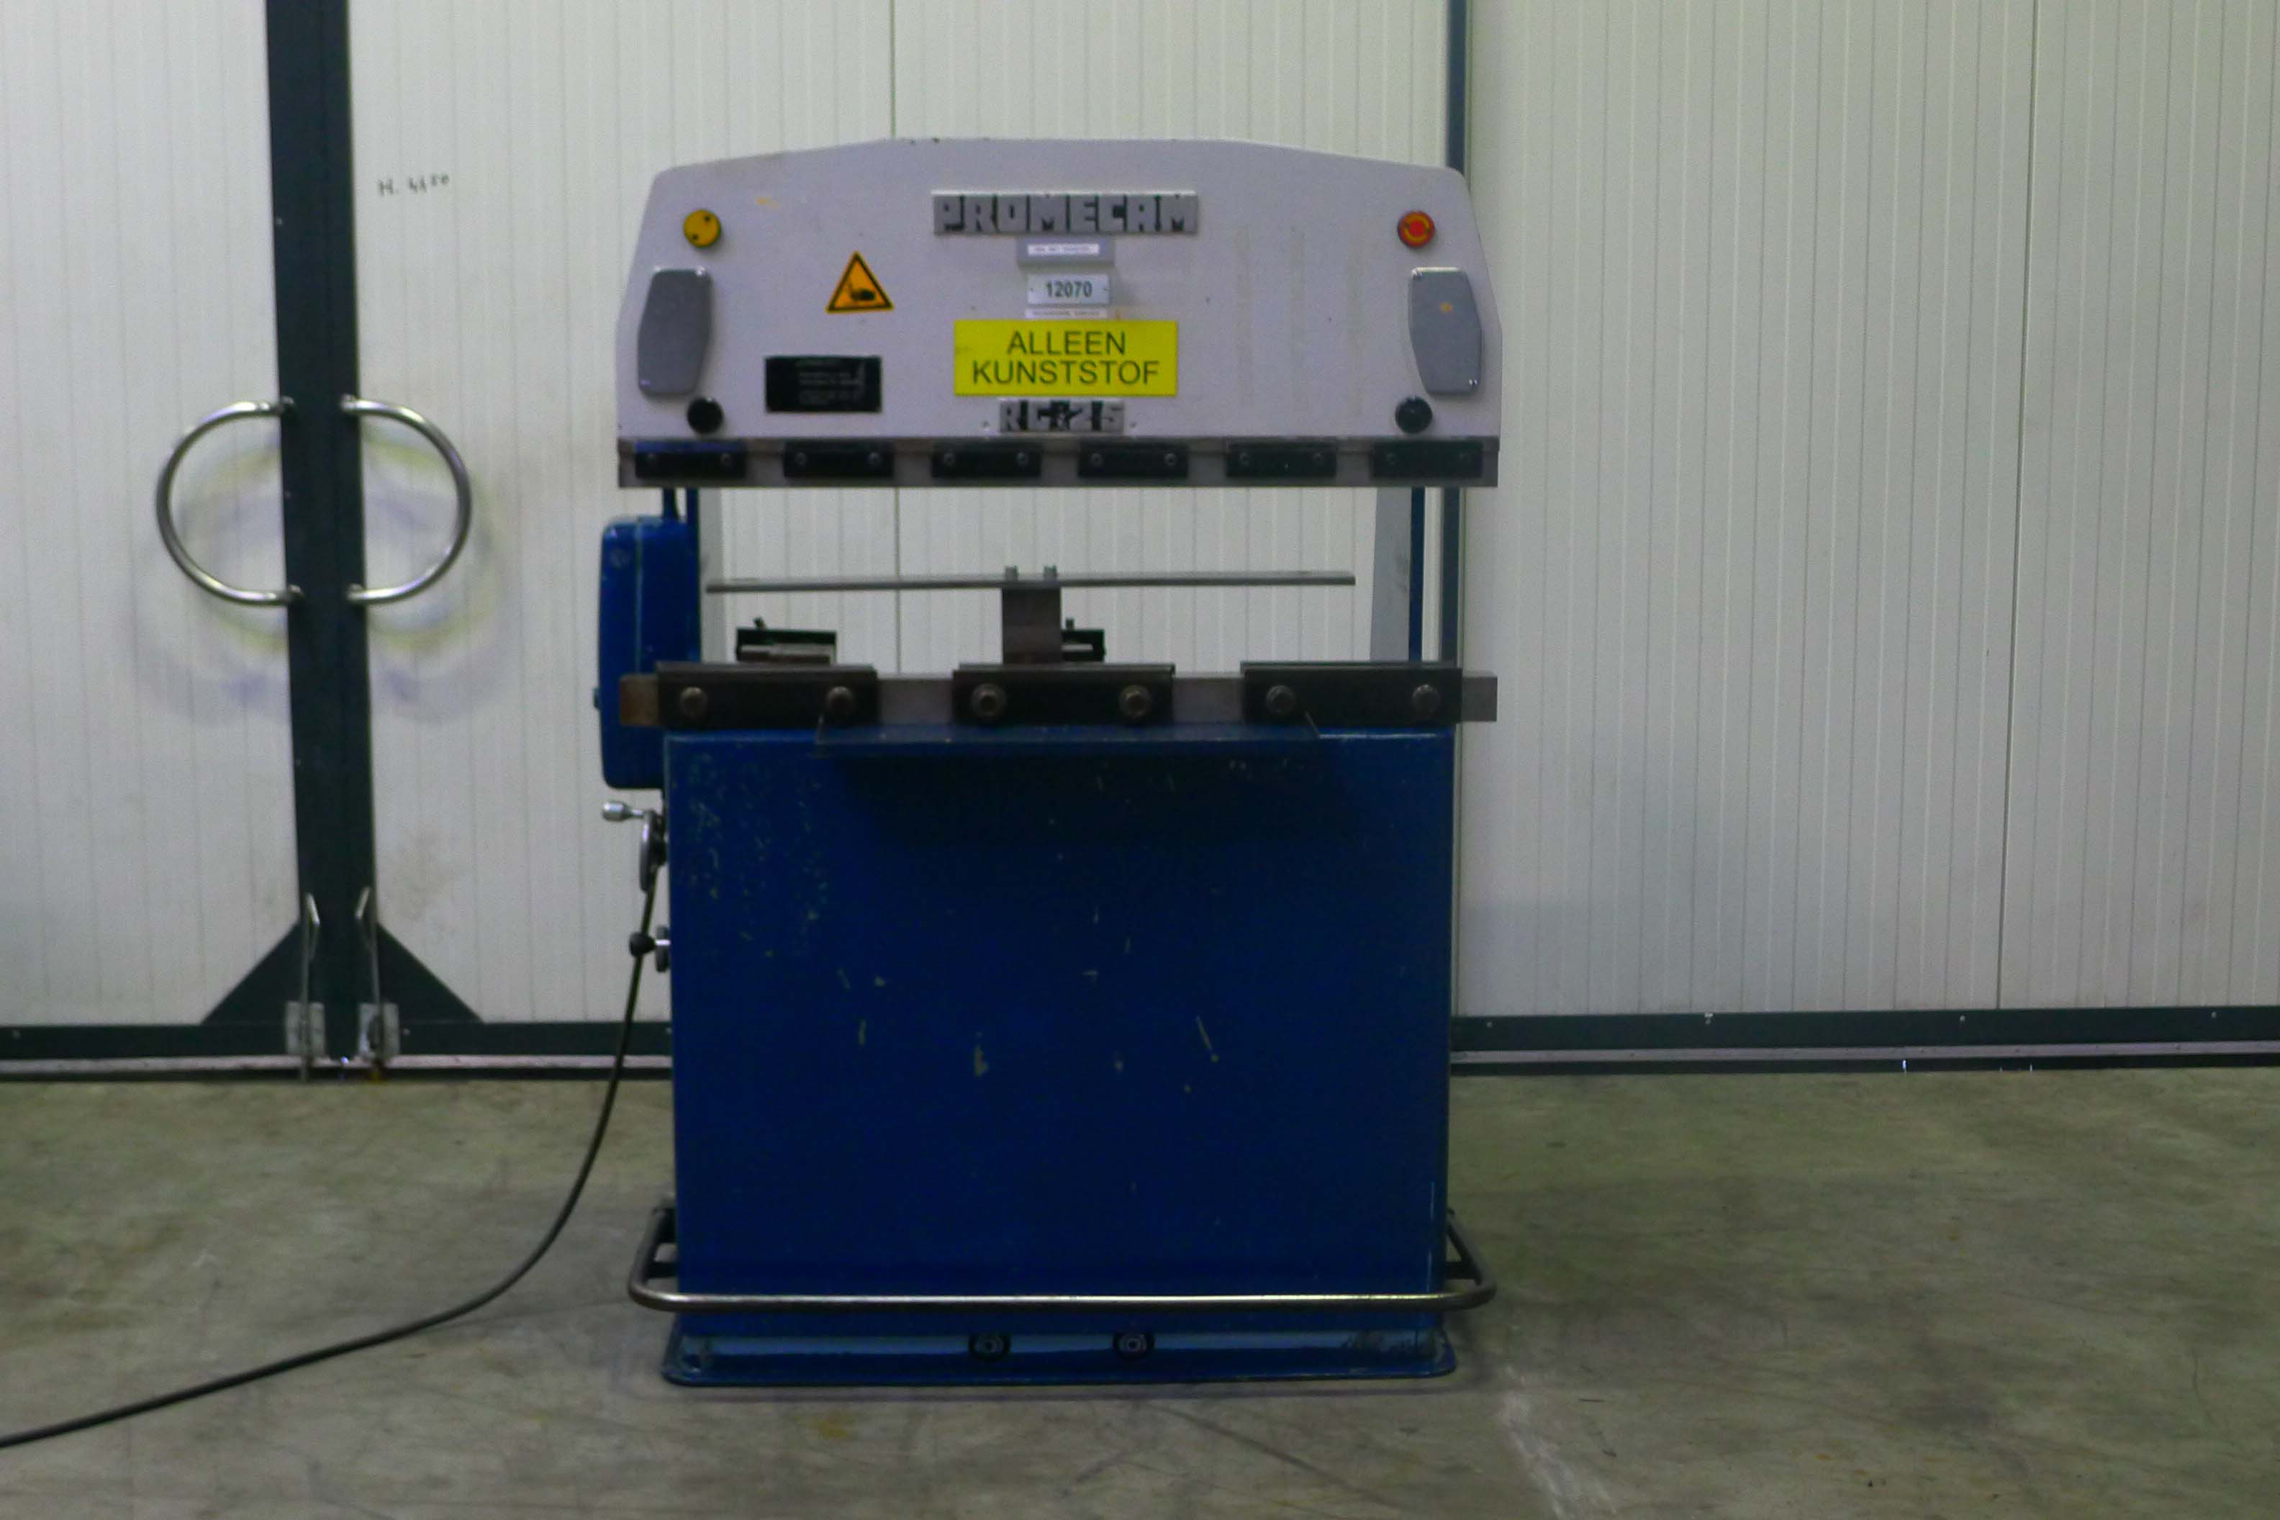
- Typ : 25 – 12 B
- No : 22979
- Age : 02/1996

- Max. bending length: 1.200 mm
- Between column : 1.020 mm
- Max. force : 25 Ton

- Beam stroke : 100 mm
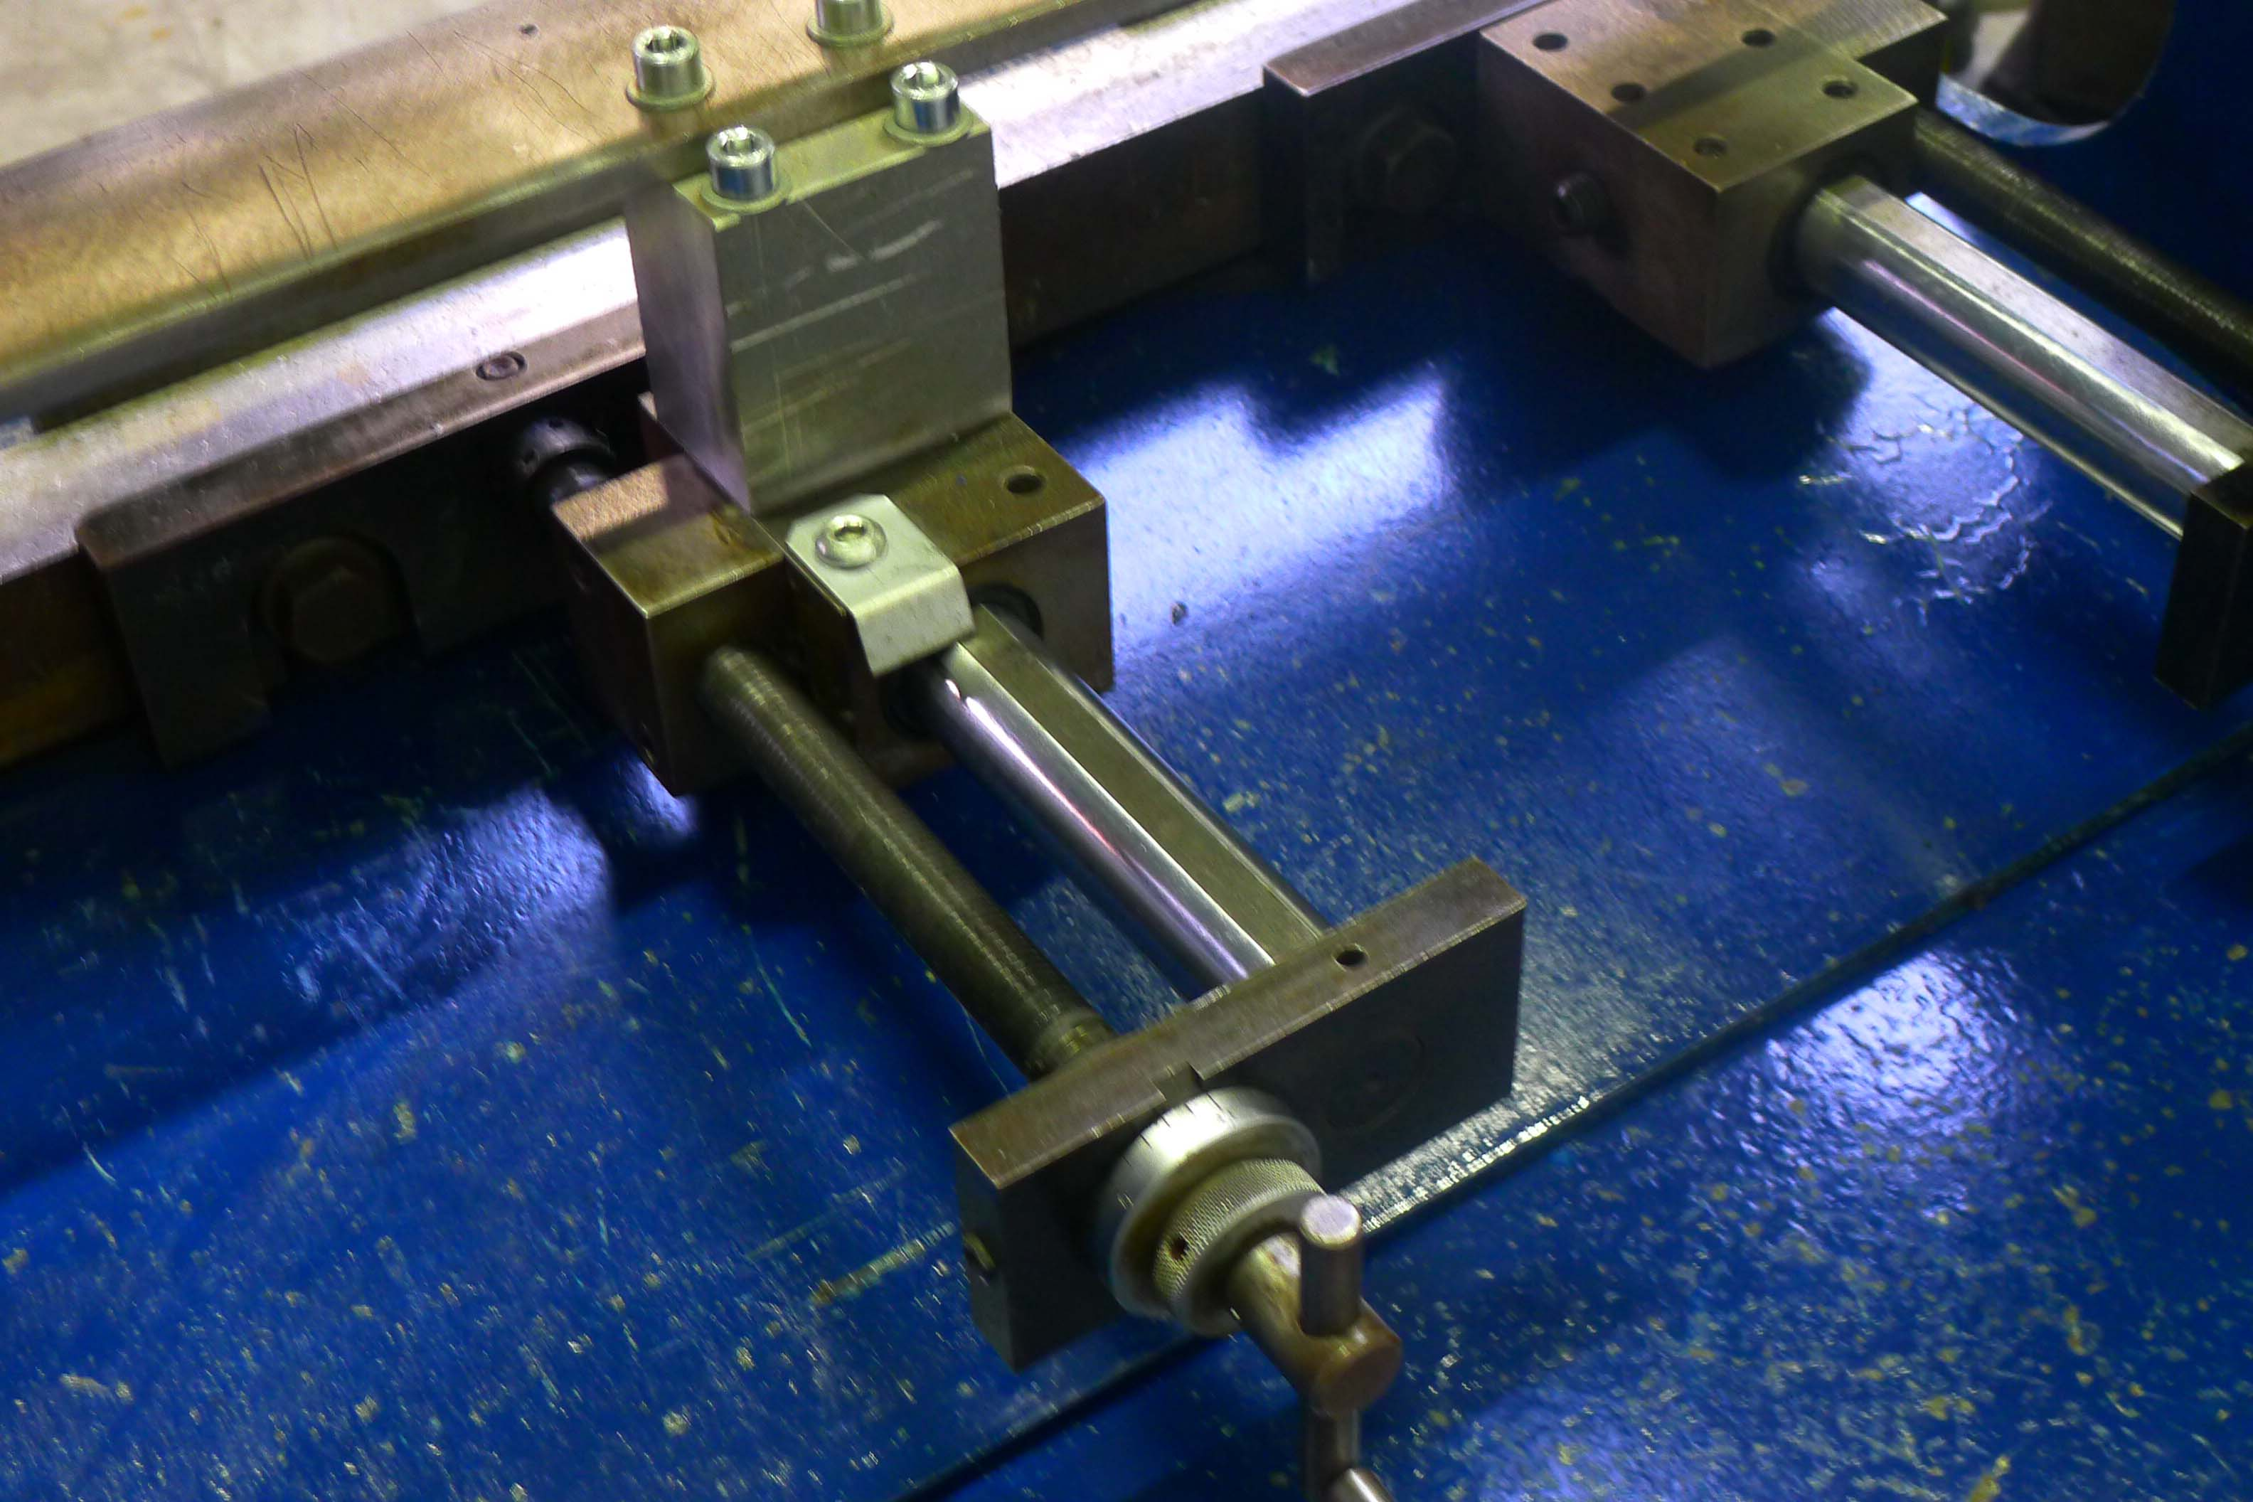
- Depth of throat : 200 mm
- Table width : 140 mm

- Approach speed : 40 mm/min
- Bending speed : 9 mm/min
- Return speed : 80 mm/min

- Backgauge 400 mm

- Dimensions
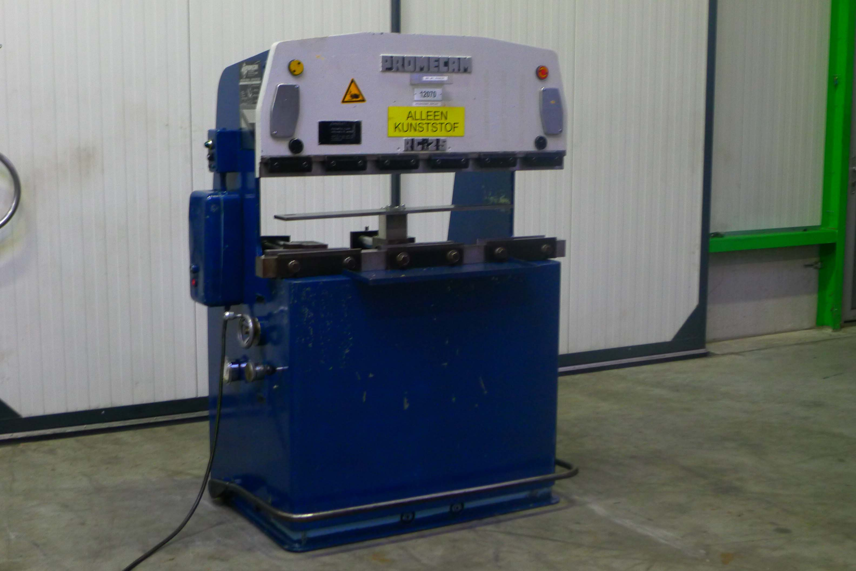
- Length : 1.200
- Width : 1.000
- Height : 1.660
- Weight : 1.000

- Power 400 V / 1.8 kW
- Incl. prospect

- Very little used !

Please Note: The above information has been obtained to the best of our ability and belief from, and from the manufacturers where possible. It is given in good faith, but its accuracy can not be guaranteed. Accordingly, it will not form a representation or constitute contractual terms. We advise you to check any vital details!

